Hands-on Activity 2.1
Data Types and Arithmetic Operations
Course Code: CPE007 | Program: Computer Engineering
Course Title: Programming Logic and Design | Date Performed: 8/4/25
Section: CPE11S1 | Date Submitted: 8/4/25
Name(s): Paula Esguerra | Instructor: Sir Jimlord Quejado
6. Output
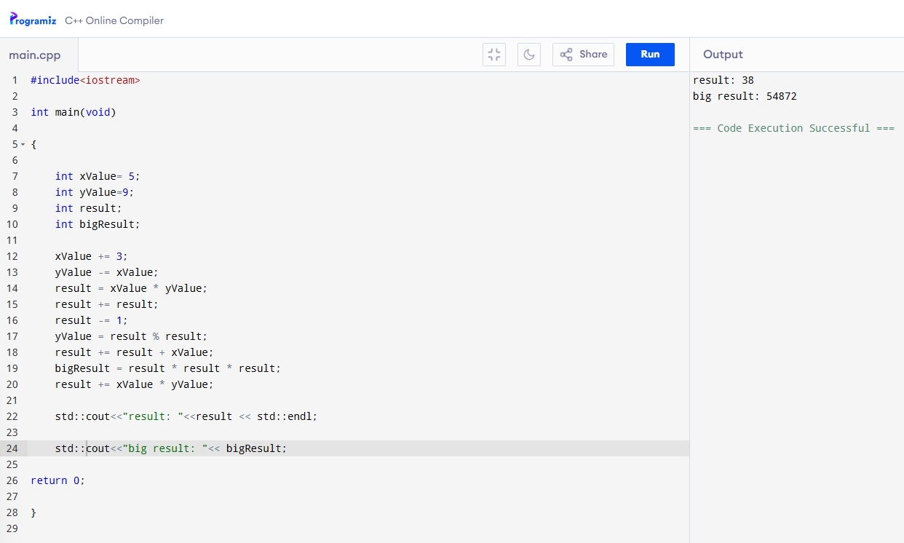Activity 1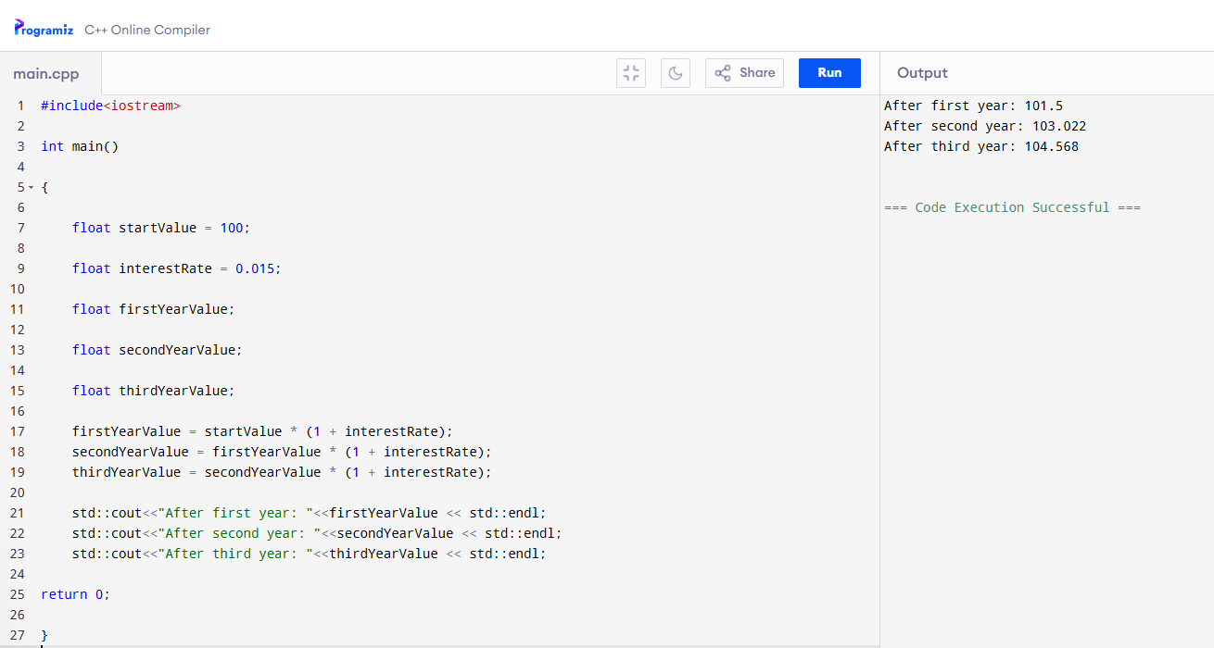Activity 2
7. Supplementary Activity
8. Conclusion
I learned that combining symbols, characters, operators and etc…, can make an interesting math solutions even with the percentage, I just have to know how to know it’s whereabouts in C++ Coding.
9. Assessment Rubric
